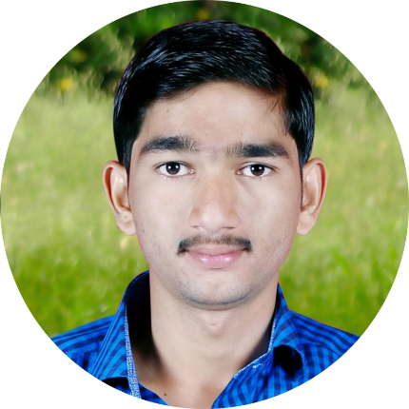

**Education**

**Master of Computer Applications**

MVJ College of Engineering

Bangalore, Karnataka (2014–2017)

**Bachelor of Computer Applications**

MDM College,

Aurad (sha), Maharashtra (2011-2014)

**Skills**

JavaScript,

TypeScript,

NodeJs,

ReactJs,

Redux,

ExpressJs,

MongoDB,

MongooseJS,

GIT,

NPM,

CSS,

HTML,

Angular,

Vue Js,

Java,

Photoshop

**Languages**

Marathi,

Hindi,

English

**EXPERIENCE**

**CloudBloom Systems LLP (Feb 2020 - present) – Full stack developer**

- Designed microservices using vue.js and implemented it in playposit product. - Developed REST services using Node-JS, Express-JS, Sequelize, Underscore-JS Body-Parser, and other node modules to serve the web application with JSON data.

**Runo Technologies (2018- 2020) – Full stack developer**

- Implement the web application using MEAN Stack technologies (MongoDB, Express, Angular 2, Node.js ) along with HTML5, CSS3, JavaScript, jQuery, Bootstrap and other web technologies.

- Developed Mean Stack application from scratch including Mongo DB server setup and NodeJS server development.

- Developed REST services using Node-JS, Express-JS, Mongoose, Underscore-JS Body-Parser, and other node modules to serve the web application with JSON data.

- Developed various screens for the front end using React JS and used various predefined components from NPM (Node Package Manager)

**Untangled Technology Solutions PVT LTD (2017-2018) – MEAN Stack developer**

- Untangled technology sol. pvt ltd | Aug 2017 - Jun 2018 Developed Mean Stack application from scratch including Mongo DB server setup and Nodejs server development.

- Built the reusable service components using Angular 2 services with Object Oriented JavaScript, JQuery, HTML, CSS3 based on the visual designs. - Involved in developing applications using Angular 2 - Bootstrap like Grids, Toolbars, Panels, Combo-Box and Button etc.

**INTEREST**









+919766999425,

+919579316613,

arun.kavale@gmail.com

I am a dedicated hard working team player with experience and excellent knowledge on cutting edge up-to-date web development technologies Angular.js, React JS,  Node JS, Express JS, Mongo DB seeking a web developer role in your company. I am willing to utilize my 3+ year of experience as MEAN stack developer and excellent creative skills for your company achieve its goals.

**PROFESSIONAL PROFILE**

Arun M. Kavale

Full Stack JavaScript Developer